

**University Staff Committee**

**Meeting Minutes**

**March 16, 2023 10:00 – 11:30 a.m.**

**Virtually on TEAMS**

1. **Call to order** – Lea Truttmann, USC Chair, called meeting to order at 10am

**2. Roll call** – Brenda Beck, Michael Bielski, Jennifer Buhr, Kate Burns, Cheryl Charon, Colleen Ciampoli, Christine Cox, Nina Dessoir, Mark Fischer, Julie Flenz, Becky Haeny, Jessica Hankemeier, Jean Haroldson, Lottie Hiben, Wendy Holschbach, Heather Jobelius, Steven Kaiser, Eric Knapowski, Jane Laurin, Carolyn Loberger, Marina Lyudmer, Kimberlee McKeefry, Kim Mezger, Steve Meyer, Jaime Miller, Theresa Mullen, Karen Murphy, Parker Nadeau, Linnea Oty, Kayle Petitjean, Jakob Pflederer, Sarah Potratz, Olivia Raasch, Brian Rabideau, Krissi Simon, Tina Tackmier, Jolene Truckenbrod, Tracy Vanerem, Rachel Wautier, Paul Wikgren, Amanda Wildenberg, Kaitlin Williams, Brynne Wolfe, Kerry Yang

1. **Approval of Minutes** – February 16 minutes approved by Becky Haeny , Mark Fischer, Heather Jobelius, Parker Nadeau.
2. **Guests:** Provost Kate Burns and Steve Meyer-speaking on the SOFAS position – Kate spoke briefly of how SOFAS is currently staffed and how the positions as well as support will be different in the future. The positions are being evaluated with possible changes and is 40% completed. We are looking at other UW schools and how they structure their SOFAS.

Kate also mentioned the Administrative Transformation Program (ATP) and discussed the goals of the program. ATP will allow us to connect our systems and rely on technology. It will also incorporate tracking promotions and tenure, as well as benefits. There would be 2 job descriptions. SOFAS resource for all shared governances and navigate rules, policies and procedures.

Steve then went through the tips he has compiled for his replacement. This position is a two year learning curve.

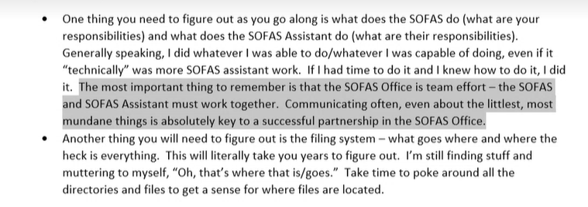

1. **Treasurer’s Report & Update** – Mark Fischer – shared our current standings in the accounts.
2. **HR Report** – Julie Flenz

* **Climate and Engagement Survey**

Reports should be out by the summer of 2023. Staff submissions were 56.4% or 304. Faculty was 30.3% or 114 submissions.

* **Annual Performance Evaluations**

Evaluations are due Friday, March 24th. Contact HR if an extension is needed. Several training sessions were held that went over changes and overviews of the Annual Performance Evaluation forms. In the sessions, an in-depth discussion was held about filling out the forms. You can find the recorded sessions on the HR website or linked in Julie Flenz report.

* **Benefits Administration Transition**

The transition that will be moving the function to UW systems and will be effective April 10th. For anything benefit related, contact the benefits counseling team. Our team will be responsible for FMLA, ADA employee well-being activities.

* **Employee Appreciation Week**

We have started planning and the estimated dates are May 1st-5th. If you’re interested in helping plan, please contact Julie Flenz or the HR office.

* **Leadership Green Bay Program**

If you’re interested in participating or nominating someone, fill out the interest form that can be found in Julie Flenz report, HR blog, and HR Connect newsletter. The forms need to be filled out and signed by the employee, supervisor, and the dean division head. Forms are due by Friday, March 31st.

* **Trainings**

Making the Most of a Multigenerational Workforce: Tuesday, March 28th at 02:00pm. Link to register is in the minutes as well as the HR blog and newsletter.

Motivate, Recognize, and Energize Employees: Tuesday, April 18th at 11:00am. The link can also be found on the HR blog.

* **Wellness Activities**

March Madness: A challenge throughout the month of March. Faculty and Staff can participate by completing activities from four different categories. They then can choose which activity they would like to advance to the next round. All completed forms must be submitted by March 31st. Participants will receive a t-shirt. More information can be found on the blog post.

Group Fitness Punch Card: Attend 12 group fitness classes this semester to receive a prize. For more information and class schedules, check out the blog post.

* **Employee Update**

Julie Flenz went over new hires as well as new positions.

1. **Committee Reports**

Election Committee – Brenda Beck – Thanks goes to Amanda Wildenberg for becoming the representative on the Awards and Recognition Committee. The Interest Survey for the upcoming elections was sent out and is open until March 23rd.

Personnel Committee – Brenda Beck – No report

Professional Development Committee – Sara Chaloupka & Jennifer Buhr – Tundra Lodge is booked, the date is Friday, September 22nd. Also booked two keynote speakers, Liz Moldenhauer and Jay Gubrud.

UW System University Staff Representative – Kim Mezger – no report

University Committee –Becky Haeny and Lea Truttmann – Main topic is the SOFAS position. For the faculty comments, they can be found in the Faculty Senate Minutes.

For an assembly meeting, April is being considered. The committee will vote about going into the summer session. The plan is to take a break for summer after the main meeting and reconvene in September. If something comes up, a random meeting can be held.

Other Campus Appointive Committees & Working Groups – no report

1. Old Business
2. Other
3. Adjournment – Meeting was adjourned at 10:53am.

The next USC meeting will be April 20, 2023 10:00 - 11:30 am, virtually on TEAMS.

**USC Members** – Lea Truttmann, Chair; Becky Haeny, Vice Chair, Mark Fischer, Treasurer, Ben Counard, member; Jules Duprey, member; Heather Jobelius, member; Parker Nadeau, member; OPEN, member, McKinley Lentz, member

