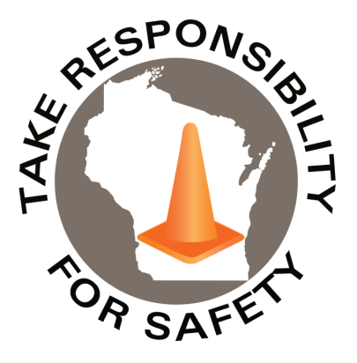

Safety Spotlight:

[National Preparedness Month](https://www.ready.gov/september#:~:text=National%20Preparedness%20Month%20is%20an%20observance%20each%20September,and%20emergencies%20that%20could%20happen%20at%20any%20time.)

Five Minutes for Safety:

[Watch out for deer!](https://www.ruralmutual.com/resource/personal/deer-safety-tips-for-avoiding-an-accident/" \l ":~:text=Follow%20these%204%20safety%20tips%20to%20reduce%20your,often%20holds%20true.%20...%204%20Buckle%20up.%20)

Flu Season is Here!

The CDC estimates there have been 390,000 to 830,000 hospitalizations due to influenza from October 1st, 2023, to June 15, 2024. The CDC [recommends](https://www.cdc.gov/flu/season/faq-flu-season-2023-2024.htm) getting vaccinated for Influenza each Fall to provide optimal protection.

Driving at Night

With earlier nightfall and the end of daylight savings coming up in November, it is a good idea to take extra care around nighttime driving. The [National Safety Council](https://www.nsc.org/road/safety-topics/driving-at-night) has safety [tips](https://www.nsc.org/getmedia/aae67435-f571-4d45-8765-a6d9f3ebe0f9/fall-driving-eng-(1).pdf.aspx) for driving at night.

September 2024

Volume 11, Number 9

|  |
| --- |
| Safety Net(work)  Produced by Department of Administration Bureau of State Risk Management  Produced by Department of Administration Bureau of State Risk Management |

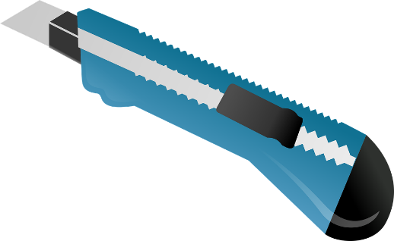

In This Issue:

**Knife Safety**

**Cleaning up Leaves**

Knife Safety

While sharper knives may cause more harm when they cut you, they are [safer](https://sharpeningstonereviews.com/sharpening-resources-and-guides/sharpening-faqs/the-science-behind-why-a-sharp-knife-is-safer-than-a-dull-one/) than dull ones: it may seem counterintuitive, but sharper knives require less force to cut and are less likely to slip while cutting. For this reason both the [National Safety Council](https://www.nsc.org/safety-first/your-only-holiday-slice-should-be-pie) and the [Ottawa Public Health](https://www.ottawapublichealth.ca/en/Public-Health-Topics/resources/Documents/knife_safety_en.pdf) discourage using dull knives.

Also, to help maintain a knife’s edge, only use knives for their specific intended purpose: for example, don’t use kitchen knives to open plastic bags and cardboard boxes or use utility knives to cut tomatoes, etc.

[Handwash](https://www.ottawapublichealth.ca/en/Public-Health-Topics/resources/Documents/knife_safety_en.pdf) knives after use (running knives through dishwasher can dull blades) and store properly in knife racks, or flat, away from any edges and away from other utensils, flames or extreme heat sources, is recommended by Ottawa Public Health.

When cutting with a knife, always keep the knife pointed away from you while cutting. Make a path for the knife to travel and [move outside](https://www.ccohs.ca/oshanswers/safety_haz/sharp_blades.html) the knife’s range of movement (based on Canadian Center for Occupational Safety and Health guidance). The National Safety Council [suggests](https://www.nsc.org/safety-first/your-only-holiday-slice-should-be-pie) to cut on steady surfaces: if a cutting board is not steady, place a wet paper towel underneath to prevent slippage.

If someone talks to you or your focus is being interrupted by distractions when you are using a knife, please set the knife aside, flat and away from any edges or to where knives could be bumped into, according to [First Benefits Mutual](https://www.firstbenefits.org/wp-content/uploads/2014/06/Knife-Safety.pdf#:~:text=Do%20not%20allow%20your%20mind%20to%20wander%20and,put%20it%20away%20immediately%2C%20and%20store%20it%20properly.).

How to avoid utility knife injuries video: <https://www.youtube.com/watch?v=V6aGpHRJ_gU&pp=ygUSYWxseSBzYWZldHkga25pdmVz>



[](https://www.travelwisconsin.com/fall-color-report)[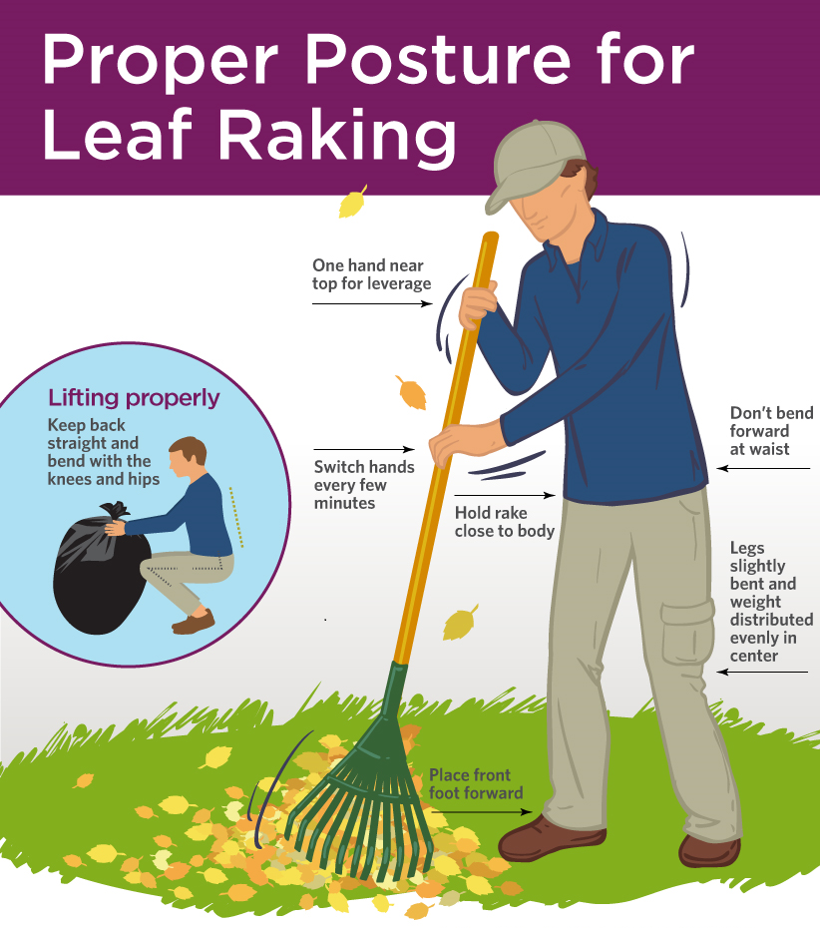](https://www.somersworthpt.com/blog/Staying-Safe-with-Fall-Yardwork~8720.html)

|  |
| --- |
|  |



Cleaning up Leaves

Fall is here! The leaves are falling, and they can be a slip hazard when wet, so it’s important to clean them up to prevent slips and falls. UW Health produced a safety [checklist](https://www.uwhealth.org/news/autumn-and-winter-safety-preventing-falls-w) for the Fall and Winter to refer to. It recommends to clear leaf piles away from porches, sidewalks, and walkways as much as possible to prevent slips and falls.

Here are some tips from BLR for cleaning up leaves at home or at work to reduce strain and prevent injuries while cleaning up leaves:

1. Grab the right type of rake for the job: get a medium-sized, sturdy rake, not one too long or too short.
   1. Short rakes can strain your back while heavy rakes add to body strain.
   2. Fan-shaped lawn rakes with flexible metal tines should be used to clear leaves. Don’t use the stone rakes to pick up leaves.
   3. Get a rake with a non-slip, padded handle to do work.
2. Inspect all rakes prior to use: if there is any damage or defects, discard and get a different tool.
3. Keep posture in mind: stand upright, pull towards you and avoid twisting and turning your back. Also try to keep wrists straight to prevent wrist strain.
4. Change it up: switch arm and leg positions to prevent repetitive motion injuries.

Enjoy the Scenery!

Mental health breaks may be beneficial to reduce workplace stress. Relax and enjoy Wisconsin’s scenic views! See the fall color report for [peak](https://www.travelwisconsin.com/fall-color-report) leaf viewing times.

Consumer Safety

[United States Consumer Product Safety Commission](http://www.cpsc.gov/)

Contact Us

<https://doa.wi.gov>

E-Mail

[Jake.Lowell@Wisconsin.gov](mailto:jake.lowell@wisconsin.gov)