Computer Workstation
Ergonomic Self-Assessment
Take a few minutes to look at your workstation. By answering a few questions, you can self-assess your workstation and help to improve your working posture. If you indicate any adjustments or concerns that cannot be self-corrected with the information provided below, contact the UW-Green Bay Safety Manager.
To understand the best way to set up a computer workstation, it is helpful to understand the concept of neutral body positioning. This is a comfortable working position in which your joints are naturally aligned. Working with the body in a neutral position reduces stress and strain on the muscles, tendons, and skeletal system and reduces your risk of developing a musculoskeletal disorder.
- Hands, wrists, and forearms are straight, in line and roughly parallel to the floor
- Head is level, or bent slightly forward, forward facing, and in line with the torso
- Elbows stay in close to the body and are bent between 90 – 120˚
- Back is fully supported with appropriate lumbar support when sitting upright or leaning back slightly

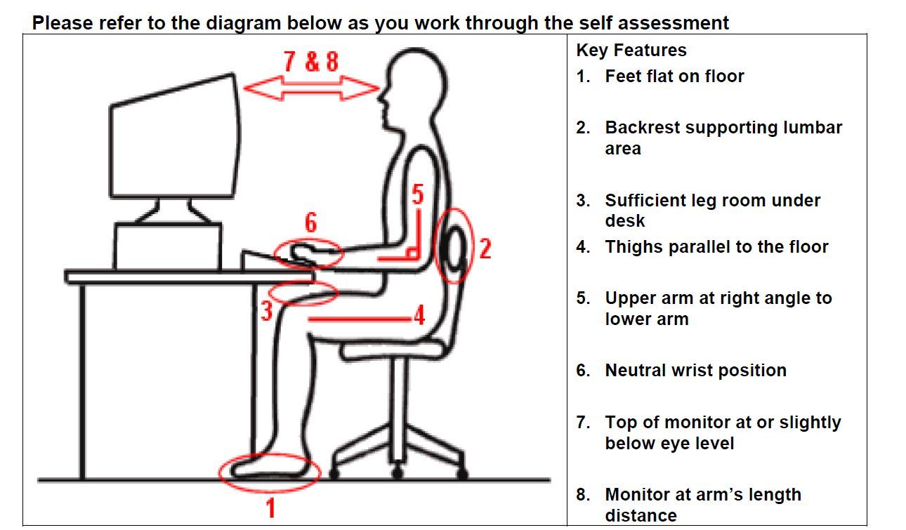

Item | Chair | Yes | No | N/A | Suggested Actions
1 | Can the height, seat and back of the chair be adjusted to achieve the posture outlined below? |  |  |  | - Obtain a fully adjustable chair
2 | Are your feet fully supported by the floor when you are seated? |  |  |  | - Lower the chair  - Use a footrest
3 | Does your chair provide lumbar support for your lower back? |  |  |  | - Adjust chair back  - Obtain proper chair  - Obtain lumbar roll
4 | When seated, are your knees bent at an approximately 90˚ angle? |  |  |  | - Raise/lower chair
5 | Is there about 2-3” between front of seat pan and back of knees (are you able to sit without feeling pressure from the chair seat on the back of your knees)? |  |  |  | - Adjust seat pan  - Add a back support
6 | Do your armrests allow you to get close to your workstation? |  |  |  | - Adjust armrests  - Remove armrests
7 | Are your arms & shoulders relaxed at your sides without interference from chair armrests? |  |  |  | - Remove armrests

Item | Keyboard and Mouse | Yes | No | N/A | Suggested Actions
8 | Are your keyboard, mouse and work surface at your elbow height? |  |  |  | - Raise / lower workstation  - Raise or lower keyboard  - Raise or lower chair
9 | Is the keyboard close to the front edge of the desk (allowing space for wrist rest, if used) and aligned with your monitor? |  |  |  | - Move keyboard to correct position
10 | When using your keyboard and mouse, are your wrists straight and your upper arms relaxed? The keyboard should be flat and not propped up on keyboard legs. An angled keyboard may place the wrist in an awkward posture when typing. |  |  |  | - Re-check chair, raise or lower as needed  - Check posture  - Check keyboard and mouse height
11 | Is your mouse at the same level and as close as possible to your keyboard? |  |  |  | - Move mouse closer to keyboard  - Obtain larger keyboard tray if necessary
12 | Do you use a soft palm/wrist rest to minimize contact pressure with hard desk surfaces?  It is important to use these pads for periodic micro-breaks and not as a means of support. |  |  |  | - Obtain soft wrist rest  - Do not use wrist rest as a means of support while typing

Item | Monitor and Work Surface | Yes | No | N/A | Suggested Actions
13 | Is your monitor positioned directly in front of you? |  |  |  | - Reposition monitor
14 | Is the top of your monitor at or just below eye level? |  |  |  | - Add or remove monitor stand  - Adjust monitor height
15 | Is your monitor and work surface free from glare? |  |  |  | - Adjust overhead lighting  - Cover windows  - Obtain antiglare screen
16 | Are frequently used items within easy reach? |  |  |  | - Rearrange workstation
17 | If you use a document holder, is it placed either beside the screen or between the screen and keyboard? |  |  |  | - Obtain document holder if needed  - Position it appropriately
18 | If you spend more than an hour a day in combined computer and phone work, do you use a headset? |  |  |  | - Obtain headset

Item | Breaks | Yes | No | N/A | Suggested Actions
19 | Do you take micro-breaks every 20 - 30 minutes? (walking, stretching) |  |  |  | - Set reminders to take breaks
20 | Do you take regular eye breaks from looking at your monitor? |  |  |  | - Refocus on distant object every 30 minutes

