HOW TO VIEW PURCHASING CARD TRANSACTIONS IN WISDM (OPTION 1)
- After logging into WISDM, click on Main Menu, Departments, Search
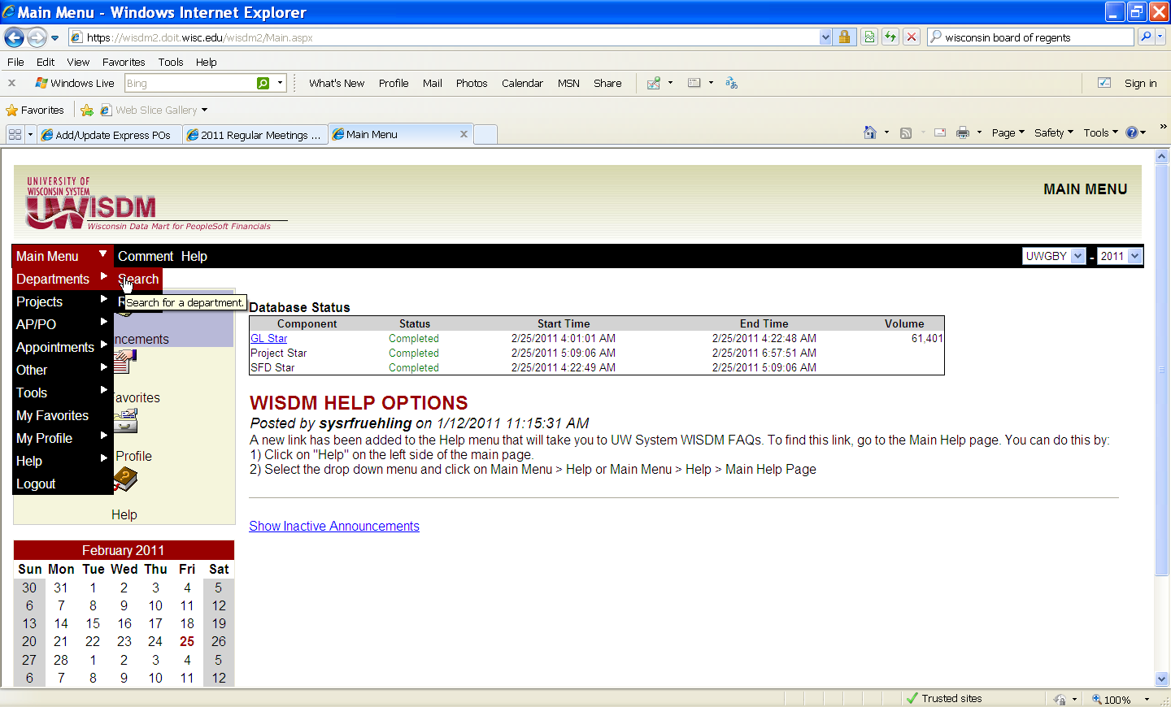

- Enter Fund and Department Code, Submit
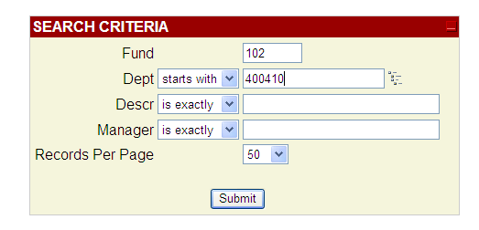

- Click on Drilldown Level, click on 3
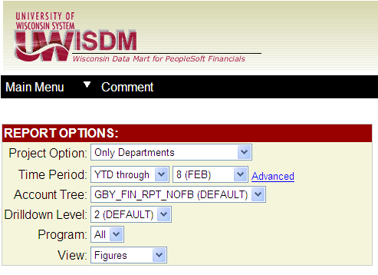
- Click on Expenses link for Supplies
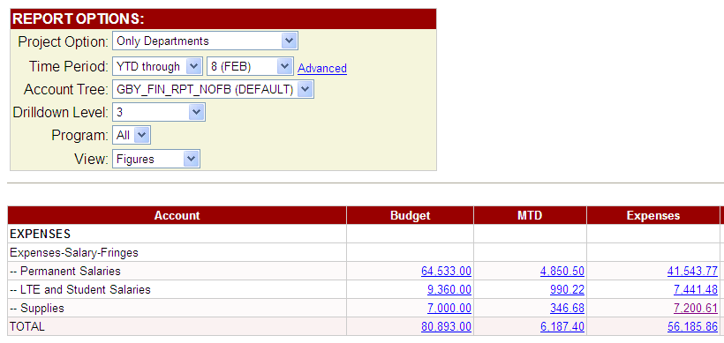
- To view the cardholder associated with a specific charge you must enable the Journal Line Reference column*:
- Click on Pick Custom Columns link in upper right corner of the screen
- Check “Journal Line Reference” located under Journals
- Click Update
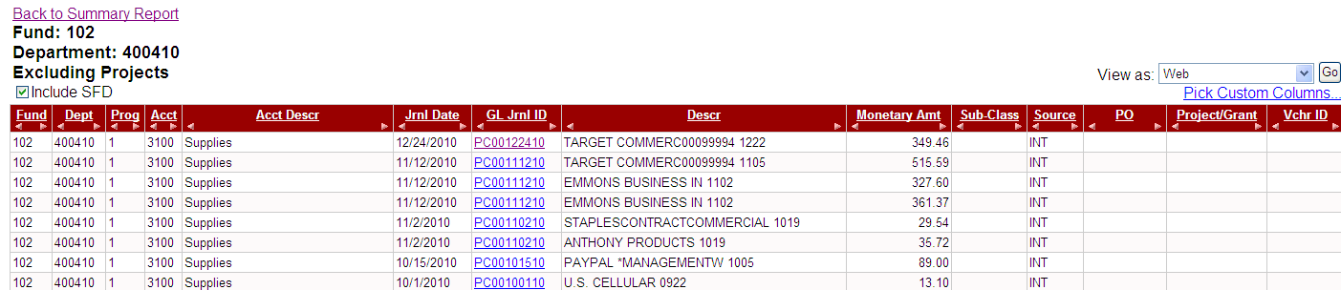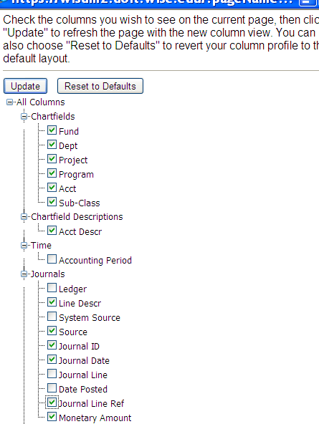
Click on Column Header “GL Jrnl ID” to sort by expense type. P-Card transactions appear with the suffix “PC”---you are able to view the vendor name, dollar amount and cardholder name.
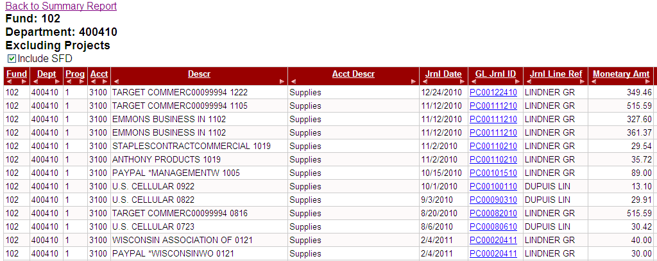
*Activation will also show the MD account number used to place orders with MDS.

HOW TO VIEW PURCHASING CARD TRANSACTIONS IN WISDM (OPTION 2)
- After logging into WISDM, select Departments & Search from the Main Menu.
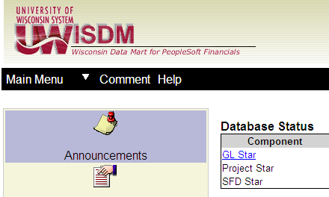
- Enter the department funding code associated with the P-Card transaction; Submit
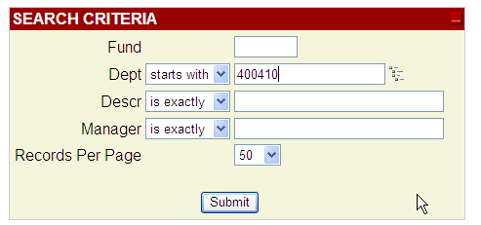

- Change Drilldown Level to 6;
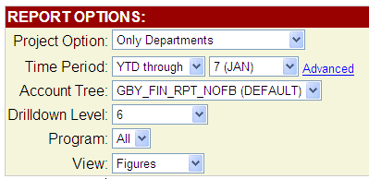
- Click on the link under the Expenses column corresponding to the account number associated with the P-Card (3100 in this example).

- Click on GL Jrnl ID column heading to sort journal entries by categories—all Purchasing Card transactions begin with PC.

- To view the cardholder associated with a specific charge you must enable the Journal Line Reference column*:
- Click on Pick Custom Columns link in upper right corner of the screen
- Check “Journal Line Reference” located under Journals
- Click Update
The following detail is now viewable:
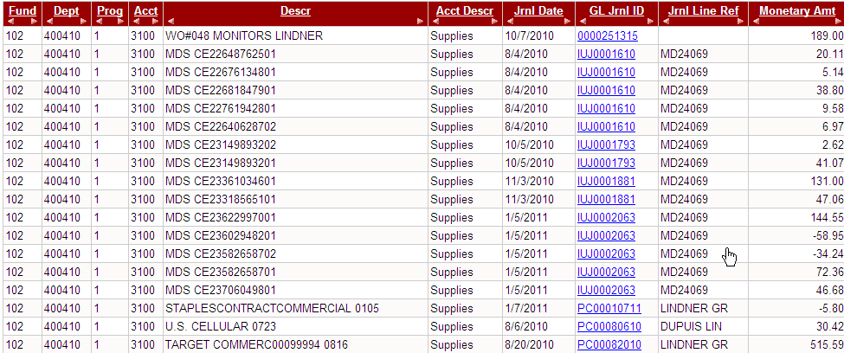
*Activation will also show the MD account number used to place orders with MDS.

